CS 590 Module Six Assignment1
1. Compare Relational, Document, and Graph Databases
a) Differences in Data Modeling
Relational databases store data in tables with rows and columns, and relationships are created using keys and JOIN operations.
Document databases store data as flexible documents, usually in JSON format. Each document can contain different fields and nested values.
Graph databases store data as nodes and relationships. Nodes represent entities, and relationships connect them. Neo4j is designed specifically for connected data.
b) Strengths and Weaknesses for Different Data Scenarios
Relational databases are best for structured data and reporting but can become slower when many JOINs are required.
Document databases are flexible and useful when the structure changes often, but managing relationships can be more difficult.
Graph databases are best for highly connected data because they make relationship traversal fast and efficient. However, they are less suited for simple table-based reporting.
For the Child Nutrition database, Neo4j is useful because nutrient values are directly connected to nutrient descriptions through the nutrient code.
2. Create a New User in the Neo4j Instance
A new user named student123 was created in the Neo4j instance using a Cypher command in Neo4j Browser.
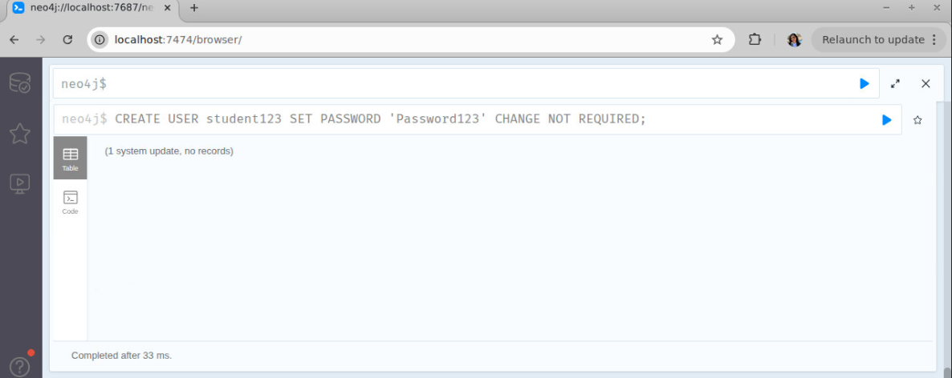
B. Instantiate the Neo4j Database
The Neo4j database was instantiated by starting the database service in Codio using the terminal command: sudo neo4j start
After starting the service, Neo4j Browser was opened and connected successfully through http://localhost:7474.
This confirmed that the Neo4j database instance was running and ready for executing Cypher queries.
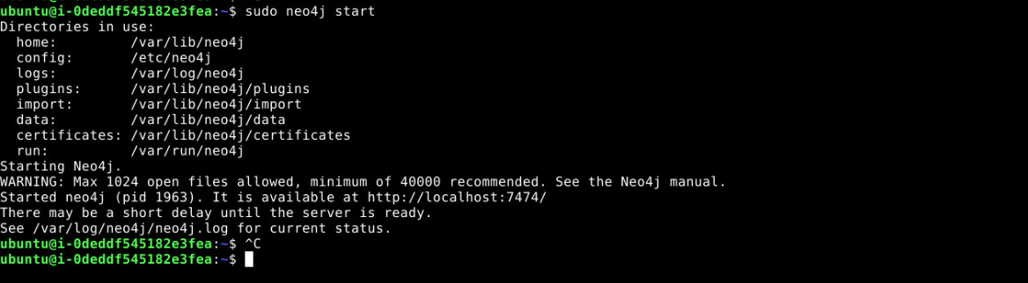
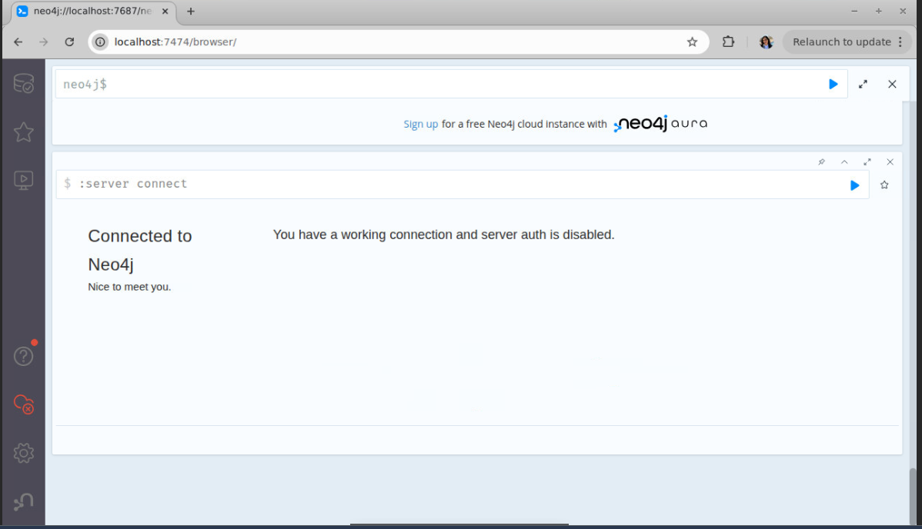
3. Implement the Provided Schema Using Nodes and Relationships
The provided schema was implemented in Neo4j using two node types : NutDes – Nutrient Description and NutVal – Nutrient Value. A relationship was created between these nodes using: INSTANCE_OF. The schema structure is: NutVal → INSTANCE_OF → NutDes
This means each nutrient value is linked to its matching nutrient description using NutrientCode. This structure allows Neo4j to represent the nutritional data as a connected graph instead of separate tables.
4. Perform Extract, Transform, and Load (ETL)
The ETL process was completed using the two provided CSV files: Module_Six_Nut_Descs.csv and Module_Six_Nut_Vals.csv
Extract: The data was extracted from the provided CSV files located in the Assignment Resources folder and copied into Neo4j’s import directory.
Transform: A transformation was required when importing the nutrient description data. The date fields in the CSV were stored in MM/DD/YYYY format, such as 10/29/1997. Neo4j could not parse this date format directly. To resolve the issue, the date fields were loaded as text strings rather than converted using Neo4j’s date() function. This allowed the original values to remain unchanged while making the import successful.
Load: After transformation, both CSV files were loaded into Neo4j successfully.
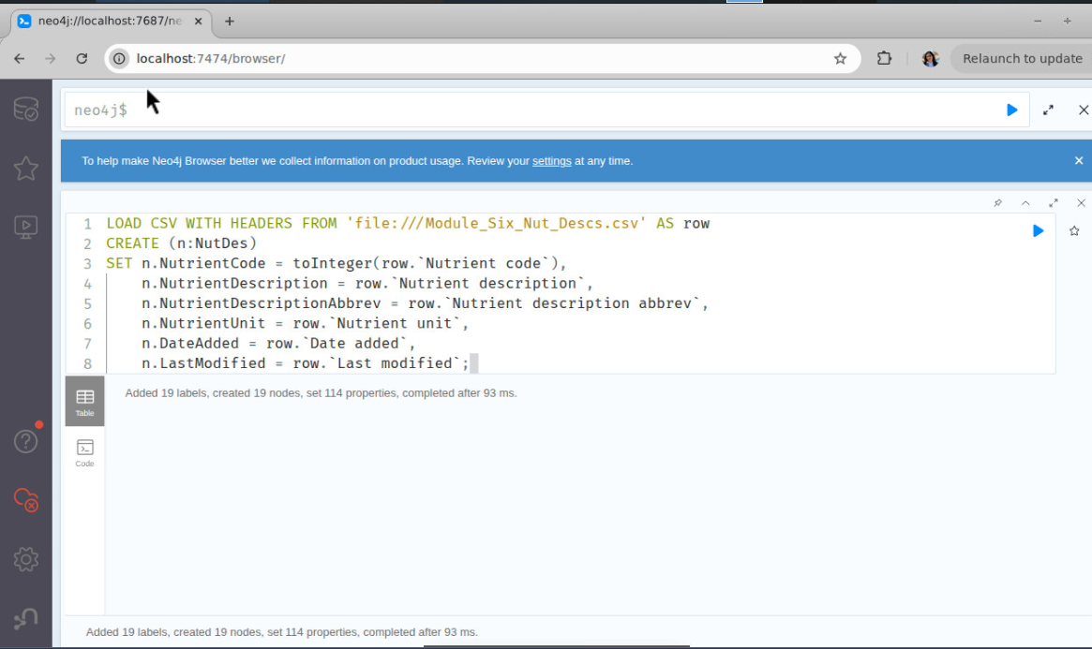
The nutrient description data created NutDes nodes, and the nutrient values data created NutVal nodes Relationships were then created between the two node types.
5. Execute the Cypher Queries
Three provided Cypher files were executed in Neo4j Browser.
Query 1: Imported Module_Six_Nut_Descs.csv and created NutDes nodes.
Query 2: Imported Module_Six_Nut_Vals.csv and created NutVal nodes.
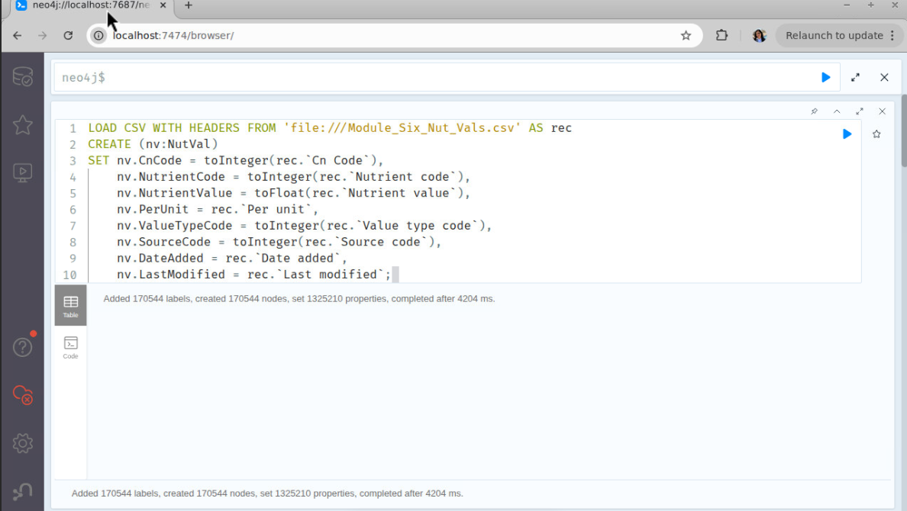
Query 3
Matched both node types using NutrientCode and created INSTANCE_OF relationships between them. The successful execution of these queries created the graph database schema and connected the nutritional data.
6. Explain How Each Cypher Query Relates to the Implemented Schema
Query 1
What it does: Imports nutrient description data from Module_Six_Nut_Descs.csv.
What it returns: Creates NutDes nodes containing nutrient description information. This forms the first part of the graph schema.
Query 2
What it does: Imports nutrient value data from Module_Six_Nut_Vals.csv.
What it returns: Creates NutVal nodes containing nutrient values and measurements. This forms the second part of the graph schema.
Query 3
What it does: Matches NutVal and NutDes nodes using NutrientCode and creates an INSTANCE_OF relationship.
What it returns: Returns connected graph data showing relationships between nutrient values and nutrient descriptions. This query completes the graph model by linking both node types together.
